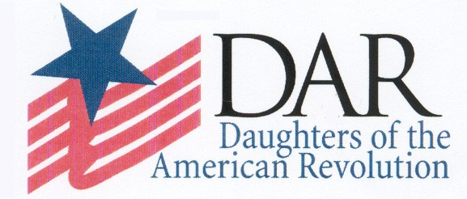 | We Want You Back! |  |  |  | We Want You Back!
Individuals leave DAR for many reasons. Throughout the years, things change in our personal lives and in our DAR chapters. Former Daughters who have resigned from our organization are no exception.  We hope that you will consider getting involved with this wonderful service organization again. Please contact me if you’re interested and I’ll help you find a chapter near you.  Kindest Regards, |  | Top Reasons to Come Back!  - You have a love for education  - You have a love for patriotism  - You have a love for historical preservation  - You feel good volunteering  - You want to be involved with a longstanding service organization  - You want to be involved with your community  - You enjoy programs and speakers  - You enjoy American History  - You like to work with people  - You like to have fun! |  | Individuals leave DAR for many reasons. Throughout the years, things change in our personal lives and in our DAR chapters. Former Daughters who have resigned from our organization are no exception.  We hope that you will consider getting involved with this wonderful service organization again. Please contact me if you’re interested and I’ll help you find a chapter near you.  Kindest Regards, |  | Top Reasons to Come Back!  - You have a love for education  - You have a love for patriotism  - You have a love for historical preservation  - You feel good volunteering  - You want to be involved with a longstanding service organization  - You want to be involved with your community  - You enjoy programs and speakers  - You enjoy American History  - You like to work with people  - You like to have fun!
 | We Want You Back! |  |  |  | We Want You Back!
Individuals leave DAR for many reasons. Throughout the years, things change in our personal lives and in our DAR chapters. Former Daughters who have resigned from our organization are no exception.  We hope that you will consider getting involved with this wonderful service organization again. Please contact me if you’re interested and I’ll help you find a chapter near you.  Kindest Regards, |  | Top Reasons to Come Back!  - You have a love for education  - You have a love for patriotism  - You have a love for historical preservation  - You feel good volunteering  - You want to be involved with a longstanding service organization  - You want to be involved with your community  - You enjoy programs and speakers  - You enjoy American History  - You like to work with people  - You like to have fun! |  | Individuals leave DAR for many reasons. Throughout the years, things change in our personal lives and in our DAR chapters. Former Daughters who have resigned from our organization are no exception.  We hope that you will consider getting involved with this wonderful service organization again. Please contact me if you’re interested and I’ll help you find a chapter near you.  Kindest Regards, |  | Top Reasons to Come Back!  - You have a love for education  - You have a love for patriotism  - You have a love for historical preservation  - You feel good volunteering  - You want to be involved with a longstanding service organization  - You want to be involved with your community  - You enjoy programs and speakers  - You enjoy American History  - You like to work with people  - You like to have fun!

